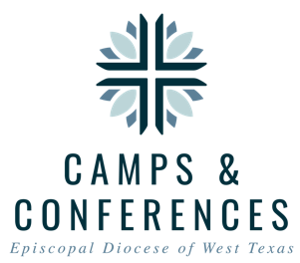
Camp Capers Scholarship Application
A typical Camp Capers scholarship is an agreement between the camper family or retreat participant, their local Episcopal church, and the Diocese/Camp Capers to each pay for 1/3 of the session registration fee.

It is the family's responsibility to register for the session first, complete the Family Portion below, ask your priest to approve and sign for the church portion, and then send this form to Camp Capers:
by fax: (830) 995-2393,
by email: camp.capers@dwtx.org, or
by mail: Camp Capers; Attn: Scholarship Application; PO Box 9; Waring, TX 78074.
If you have questions, contact the Camp Capers Office Manager, (camp.capers@dwtx.org; 830-995-3966) or Camps & Conferences Director, Rob Watson (rob.watson@dwtx.org).

Family Portion:
Camper Name: Session Attending:
Parent/Guardian Name: Email Address:
Home Address: _______________________________________ Parent Phone Number:
I hereby certify that the above information is true and accurate the best of my knowledge and that this application is made in good faith, with no intent to misinterpret the applicant's circumstances.
Parent/Guardian Signature: (Date)
Scholarship Amount requested if you are not asking your church: ____________
Church Portion: required if you are asking your church to supply a portion of the scholarship.

Church Name: (City)
Priest's Name: Email Address:
Phone Number: Church Scholarship Amount:
I hereby certify that the above information is true and accurate the best of my knowledge and that this application is made in good faith, with no intent to misinterpret the applicant's circumstances.

Priest Signature: (Date)
Office Use Only: please do not write below this line Date Received:_______
Priest Signature: [ ] Church Portion Received: [ ] Date: _______ Church Portion Applied: [ ]
DWTX Amount Requested: Approved: Yes [ ] No [ ] Initials: _____ Date:
Applied To Camper Registration:[ ] Date: ___ Family Notified: [ ] Paid In Full: [ ] Date: _

